FACULTY OF COMPUTING

CS-2134
Database Systems
Lab Manual

Table of Content

Week 1 File Handling 3
Week 2 Entity Relationship Diagram(ERD) 7
Week 3 Relational Mapping 10
Week 4 Data Definition Language 12
Week 5 Data Manipulation Language 14
Week 6 Join and Aggregate function 16
Week 7 Subquery 18
Week 8 Correlated Subquery 20
Week 9 View and Stored Procedure 23
Week 10 Functional Dependancy 25
Week 11 Normalization 27
Week 12 MongoDB Installation 31
Week 13 MongoDB Function 33
Week 14 MongoDB Projection and Filtering 38

Week1
FILE HANDLING

Lab Objective:
- To understand file handling in C++.
- To simulate a simple database using file handling.
- To perform CRUD (Create, Read, Update, Delete) operations on data stored in a file.
File Handling:
Part 1: Define Data Structure
Define a data structure to represent each record. For example, a Student struct for storing a student's details.
struct Student {
int id;
char name[50];
int age;
char address[100];
};

Part 2: File Operations
1. Creating a New Record:
  - Prompt the user for the student’s details.
  - Append this information to a text or binary file.
2. Reading Records from the File:
  - Open the file in read mode.
  - Read and display each record until the end of the file is reached.
3. Updating a Record:
  - Open the file in read mode to locate the record to update.
  - Copy all records to a temporary file, updating the specific record.
  - Replace the original file with the updated temporary file.
4. Deleting a Record:
  - Similar to updating, create a temporary file with all records except the one to delete.
  - Replace the original file with the updated temporary file.

Sample Code:

1. Create a New Record
#include <iostream>
#include <fstream>
#include <cstring>

struct Student {
int id;
char name[50];
int age;
char address[100];
};

void addStudent() {
Student s;
std::ofstream file("students.dat", std::ios::binary | std::ios::app);

std::cout << "Enter Student ID: ";
std::cin >> s.id;
std::cout << "Enter Name: ";
std::cin.ignore();
std::cin.getline(s.name, 50);
std::cout << "Enter Age: ";
std::cin >> s.age;
std::cout << "Enter Address: ";
std::cin.ignore();
std::cin.getline(s.address, 100);

file.write(reinterpret_cast<char*>(&s), sizeof(s));
file.close();

std::cout << "Record added successfully!\n";
}

2. Read Records
void readStudents() {
Student s;
std::ifstream file("students.dat", std::ios::binary);

if (!file) {
std::cout << "Error opening file.\n";
return;
}

while (file.read(reinterpret_cast<char*>(&s), sizeof(s))) {
std::cout << "ID: " << s.id << "\n";
std::cout << "Name: " << s.name << "\n";
std::cout << "Age: " << s.age << "\n";
std::cout << "Address: " << s.address << "\n\n";
}

file.close();
}

3. Update Record

void updateStudent(int id) {
Student s;
bool found = false;
std::ifstream file("students.dat", std::ios::binary);
std::ofstream tempFile("temp.dat", std::ios::binary);

while (file.read(reinterpret_cast<char*>(&s), sizeof(s))) {
if (s.id == id) {
std::cout << "Enter new Name: ";
std::cin.ignore();
std::cin.getline(s.name, 50);
std::cout << "Enter new Age: ";
std::cin >> s.age;
std::cout << "Enter new Address: ";
std::cin.ignore();
std::cin.getline(s.address, 100);
found = true;
}
tempFile.write(reinterpret_cast<char*>(&s), sizeof(s));
}

file.close();
tempFile.close();

remove("students.dat");
rename("temp.dat", "students.dat");

if (found)
std::cout << "Record updated successfully!\n";
else
std::cout << "Record not found.\n";
}

4. Delete Record

void deleteStudent(int id) {
Student s;
bool found = false;
std::ifstream file("students.dat", std::ios::binary);
std::ofstream tempFile("temp.dat", std::ios::binary);

while (file.read(reinterpret_cast<char*>(&s), sizeof(s))) {
if (s.id != id) {
tempFile.write(reinterpret_cast<char*>(&s), sizeof(s));
} else {
found = true;
}
}

file.close();
tempFile.close();

remove("students.dat");
rename("temp.dat", "students.dat");

if (found)
std::cout << "Record deleted successfully!\n";
else
std::cout << "Record not found.\n";
}

Lab Tasks:

1. Implement each function in separate modules and test for correctness.
2. Create a menu-driven program that allows the user to:
  - Add a new record
  - View all records
  - Update a record
  - Delete a record
3. Test the program by adding, updating, and deleting several records.

Week2
ENTITY-RELATIONSHIP DIAGRAM (ERD)

Lab Objectives:
- Develop skills in designing ERDs to model complex real-world systems with interrelated entities, attributes, and constraints.
- Understand how to represent relationships like many-to-many, hierarchical structures, and temporal data.

Entity-Relationship Diagram (ERD)
is a graphical representation of the entities, attributes, and relationships within a database system. It is used in database design to visually model how data is structured and interconnected.
Components ERD:
- Entities: Represent objects or concepts in the system (e.g., Customers, Orders, Products). They are depicted as rectangles.
- Attributes: Represent details or properties of an entity (e.g., CustomerName, OrderDate). Attributes are depicted as ovals connected to their respective entities.
- Relationships: Represent associations between entities (e.g., "places an order"). These are depicted as diamonds connecting entities.
- Cardinality: Indicates the number of occurrences in a relationship (e.g., one-to-many, many-to-many).
- symbols:
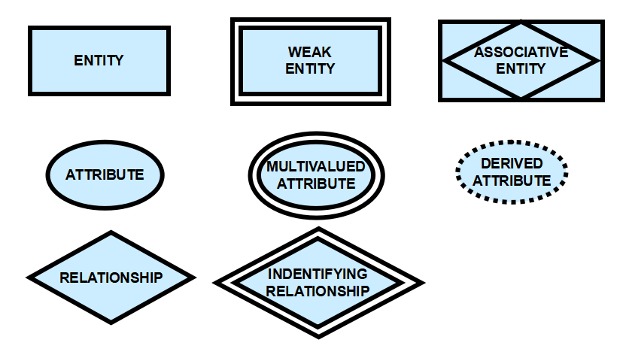

Purpose:
- To provide a clear structure for database development.
- To ensure data is logically organized and relationships are accurately defined.
- To serve as a blueprint for implementing the database in a database management system (DBMS).

LAB TASKS:
Question 1: Design an ERD for an Airline Reservation System:
• There are Flights (FlightID, DepartureTime, ArrivalTime, Source, Destination).
• Each Passenger (PassengerID, Name, PassportNumber) can book multiple flights.
• Each flight has one or more Pilots (PilotID, Name, LicenseNumber), and each pilot can fly
multiple flights.
• Passengers can also request special Meals (e.g., MealID, MealType).
Model this system to reflect the relationships between Passengers, Flights, Pilots, and Meals.

Question 2: Design an ERD for a Hotel Booking System:
• Guests (GuestID, Name, Phone) can book rooms in Hotels (HotelID, HotelName,
Address).
• Each hotel has different types of Rooms (RoomID, RoomType, PricePerNight).
• A Reservation (ReservationID, CheckInDate, CheckOutDate) is made by guests for
specific rooms, but rooms cannot be double-booked for overlapping dates.
Your ERD should account for guests making reservations for multiple hotels and rooms, with the
availability of rooms being considered.
Scenario # 1
A hospital information system manages patients, medical staff, and appointments. Patients are identified by a unique medical record number and have attributes like name, date of birth, and insurance information. Medical staff includes doctors, nurses, and other healthcare professionals, each with a unique ID, name, specialty (for doctors), and contact information. Patients can schedule appointments with various medical staff, and each staff member can have appointments with multiple patients. The system tracks the date and time of the appointment, the type of appointment (e.g., consultation, surgery), and the attending medical staff member(s).

Scenario # 2
A social media platform manages user accounts, posts, and connections.Users have a unique user ID, username, and profile information like name, location, and interests. Users can create and share posts containing text, images, or videos. Posts are identified by a unique post ID and have attributes like timestamp, content, and privacy settings. Users can follow other users to see their posts. They can also like, comment on, and share other users' posts. The system tracks the relationships between users (who follows whom) and interactions with posts (likes, comments, shares).
Scenario # 3
An online food delivery service manages restaurants, menus, orders, and deliveries. Restaurants are identified by a unique restaurant ID and have name, cuisine type, location, and operating hours. Menus consist of individual food items, each with a name, description, price, and potentially options for customization. Customers can browse menus from different restaurants, place orders, and choose a delivery method (e.g., immediate, scheduled). Orders are identified uniquely and track customer information, items ordered, total price, and delivery status. Delivery personnel are identified by a unique ID and may have associated information like name, vehicle type, and contact information. The system tracks deliveries assigned to specific personnel and manages the delivery dispatch process.

Submission Guidelines:
- Design the ERD on paper, take a clear snapshot, and paste it into a Word document with your name and student ID.
- Save the file with an appropriate name (e.g., "ERD_Task_YourName.docx") and upload it to Molliem.
- Ensure the document is clear and complete and submit it before the deadline.

Week 3

RELATIONAL MAPPING

Lab Objective:
- To learn the principles of relational database design.
- To develop ER diagrams for various use cases.
- To mapping ER diagrams to relational tables.
- To implement the tables in SQL using the mapped relational schema.

Relational Mapping:
Design an ER Diagram
Converting ER Diagram to Relational Schema Entity Mapping
- One-to-One: Create a foreign key in one of the connected entities.
- One-to-Many: Add a foreign key to the "many" side that references the "one" side.
- Many-to-Many: Create a new table (an associative table) using the primary keys of both entities as foreign keys.

Tasks:

Draw Relational mapping from ERD on the above mentioned scenario
Q1. Business Case: Pak Wheels

Pak Wheels offers to its customers the option of purchasing a car using repayment schemes of over 1 year, 2 years, 3 years, 4 years or 5 years. A customer may purchase one or more cars under the scheme. When a customer purchases a car, he or she gets to choose one of the repayment scheme options for each purchase or may pay the whole amount in one go, meaning a repayment scheme option may be selected by one or more customers or may not be selected at all. A customer will have a unique customer number, a name, an address, and a phone number. A repayment scheme option will have a unique repayment scheme number, a name and the number of years for repayment. A car will have a unique car code, a make, a model, year of manufacture and a price. The company pays commission on sales of cars to its salespeople and therefore it will also keep information about each sale which will include a unique sales ID and commission to be paid on that sale. The company will also want to know who made the sales and the car involved in that transaction so that the commission can be determined. A salesperson will have a unique salesperson ID, a name, a phone number and an email address.
Q2. Business Case: Vaccination Center
Expo center Lahore is providing facilities of Vaccination in which they have vaccination staff, Citizen, Vaccination record and Halls. Vaccination staff has its own identity from ID, Name, qualification, Designation, Age and Salary. They also have Vaccination record in which they will maintain Vaccination number, Company name, Age group and quantity. Citizen who has CNIC, name, age, blood group, blood pressure, date of vaccination and vaccination number will be maintain in Citizen record. They are also maintaining record of each citizen in Citizen details in which they are maintaining CID, Citizen type (Doctor, Teacher, Disable or others), No of doses, Side effect (if any). There are 4 halls one for doctors one for teachers one for disable and one for others. On entry you will go to specific hall in which they will give you slip that may contain hall No, Citizen CNIC, Designation, Citizen type. Vaccination staff has many vaccinations and they are maintaining record of each vaccination. Each citizen is allowed only one vaccine at a time. Each hall has many citizens in which they are entry record of each citizen and give you slip in which your record is mentioned.
Relational mapping from ERD on the above mentioned scenario

Week4

DATA DEFINITION LANGUAGE

Lab Objectives:
- Introduce students to Data Definition Language (DDL) commands for creating, modifying, and managing database structures.
- Enable students to design and implement database schemas effectively using commands like CREATE, ALTER, DROP, and TRUNCATE.
DDL (Data Definition Language) is a subset of SQL used to define, modify, and delete the structure of database objects such as tables, schemas, indexes, and views. It focuses on specifying how the data is organized within the database.

DDL Commands Example:
CREATE: CREATE TABLE Employees (
EmployeeID INT PRIMARY KEY,
Name VARCHAR(50),
Department VARCHAR(50))
ALTER: ALTER TABLE Employees ADD Salary DECIMAL(10, 2);
DROP: DROP TABLE Employees;
TRUNCATE: TRUNCATE TABLE Employees;
RENAME: RENAME TABLE Employees TO Staff;

Purpose:
- To define the database schema.
- To make changes to the structure of existing objects.
- To manage and clean up database objects as needed.

LAB TASKS:
1. Write a DDL query to create a table called Employee with the following columns and constraints:
- EmployeeID, Integer, primary key.
- FirstName, Varchar(50), cannot be null.
- LastName: Varchar(50), cannot be null.
- DateOfBirth: Date, cannot be null.
- Salary: Decimal(10,2), default value of 50000.00.
2. Given a table Department with columns DepartmentID (Primary Key) and DepartmentName, write a DDL query to create a table EmployeeDetails with the following structure and constraints:
- EmployeeID: Integer, primary key.
- DepartmentID: Integer, foreign key referencing DepartmentID in the Department table.
- Position: Varchar(30).
- JoiningDate: Date, cannot be null.

3. Write a DDL query to add a new column called Email (Varchar(100)) to the Employee table, which should not accept null values.
4. The Employee table has an Email column. Write a DDL query to add a unique constraint to the Email column to ensure no two employees have the same email address.
5. Write a DDL query to drop the EmployeeDetails table from the database. Include a check to avoid an error if the table does not exist.
6. Assume the Salary column in the Employee table needs to accommodate larger amounts. Write a DDL query to change the data type of Salary to Decimal(15,2).
7. The Employee table has a column named DateOfBirth that is no longer needed. Write a DDL query to remove this column from the table.
8. Write a DDL query to rename the EmployeeDetails table to StaffDetails.

Submission Guidelines:
- Write your query on Oracle, take a clear snapshot, and paste it into a Word document with your name and student ID.
- Save the file with an appropriate name (e.g., "Lab 4_Task_YourSAP.docx") and upload it to Molliem.
- Ensure the document is clear and complete and submit it before the deadline.

Week 5

DATA MANIPULATION LANGUAGE

Lab Objectives:
- Introduce students to Data Manipulation Language (DML) commands for interacting with data in relational databases.
- Enable students to perform essential data operations like SELECT, INSERT, UPDATE, and DELETE to manage and retrieve information from tables effectively.
DML (Data Manipulation Language) is a subset of SQL used to interact with and manipulate data within database tables. It focuses on retrieving, inserting, updating, and deleting data.

Common DML Commands:
- SELECT: SELECT * FROM Employees WHERE Department = 'Sales';
- INSERT: INSERT INTO Employees (EmployeeID, Name, Department) VALUES (101, 'John Doe', 'Sales');

- UPDATE: UPDATE Employees SET Department = 'Marketing' WHERE EmployeeID = 101;
- DELETE: DELETE FROM Employees WHERE EmployeeID = 101;

Purpose:
- To allow users to interact with and modify the data stored in a database.
- To facilitate CRUD (Create, Read, Update, Delete) operations in applications.
- To manage and query data efficiently for analysis and reporting.

LAB TASKS:
Consider following Schema of Hotel reservation system:
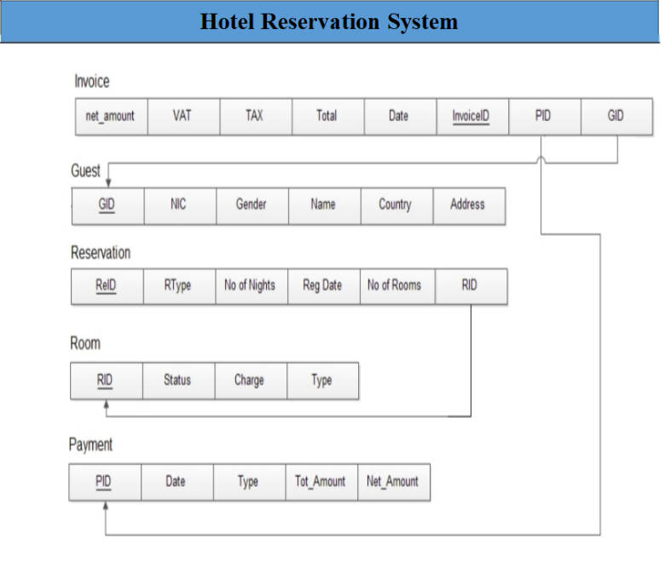
Task 1 : Management of Serena hotel wants to automate their reservation system. For this purpose we developed a schema of reservation system. So your task is to create a new database “Hotel Reservation System” and all tables with their defined keys and constraints, which are given in the above schema.
Task 2 : Insert at least 2 records in each Table according to your choice.
Insert in payment table :
PID = 1
Date : 2020-12-11
Type: Cash
Total_Amount: 1000
Net_Amount: 25000
Task 3 : Update Record in Payment Table Type: credit card where PID = 1
Task 4 :Delete Record of Payment Table where PID = 1

Submission Guidelines:
- Write your query on Oracle, take a clear snapshot, and paste it into a Word document with your name and student ID.
- Save the file with an appropriate name (e.g., "Lab 4_Task_YourSAP.docx") and upload it to Molliem.
- Ensure the document is clear and complete and submit it before the deadline.

Week 6
JOIN AND AGGREGATE FUNCTION

Lab Objectives:
- Familiarize the students with different methods to obtain data from more than one table using different types of joins
- Familiarize with the use of aggregate functions and group by clause

Joins:
Sometimes you need to use data from more than one table. In the example in the slide, the report displays data from two separate tables:
- Employee IDs exist in the EMPLOYEES table.
- Department IDs exist in both the EMPLOYEES and DEPARTMENTS tables.
- Department names exist in the DEPARTMENTS table.
To produce the report, you need to link the EMPLOYEES and DEPARTMENTS tables, and access data from both of them.
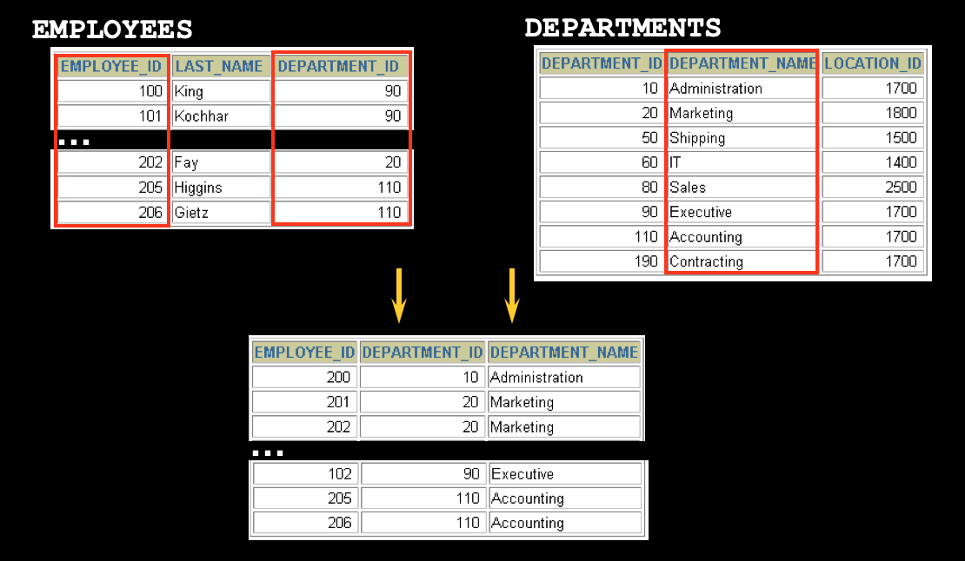

Syntax:

SELECT * FROM SAMP.EMPLOYEE INNER JOIN SAMP.STAFF ON EMPLOYEE.SALARY < STAFF.SALARY

SQL Aggregation
SQL aggregation is the task of collecting a set of values to return a single value. It is done with the help of aggregate functions, such as SUM, COUNT, and AVG. Aggregation in SQL is, typically, used in conjunction with grouping. The Group By clause is used to arrange rows into groups in SQL.

​​Aggregate Functions

SUM( ), MIN( ), MAX( ), COUNT( ), AVG( ), STD( ), VARIANCE( )

Syntax:
SELECT column_1, function_name(column_2) FROM table_name WHERE [condition]
GROUP BY column_name HAVING [condition]

LAB TASKS:

Create tables and insert data into it using the schema provided to you. Then perform the tasks below.

- Display the titles and credit hours of all the courses in the Computer Science department that have 3 credits.
- Find the name of the professor with the highest salary in the “Urban Design and Planning” department. Display the name in all upper case.
- Extract the student id, name and GPA of all the students. Display the name in all lower case. The formula for finding GPA is:
Total Earned Credits =earned credit hours in the course x credit hours of that course
GPA= total earned credits/ total credits hours of all courses in semester
- Display course id and total number of students in that course, name the column as Student Count Per Course. Sort the result in descending order.
- Display the department id and total number of courses offered by each department. Name the column as course_count.
- Find the average age of students. Name the result as “Average Student Age”.

Week 7

SUBQUERY

Lab Objectives:

- Familiarize the students with nested queries

Nested Queries:
A subquery is a SELECT statement that is embedded in the clause of another SELECT statement. You can build powerful statements out of simple ones by using subqueries. They can be very useful when you need to select rows from a table with a condition that depends on the data in the table itself.
You can place the subquery in a number of SQL clauses, including the following:
• WHERE clause
• HAVING clause
• FROM clause
Syntax: 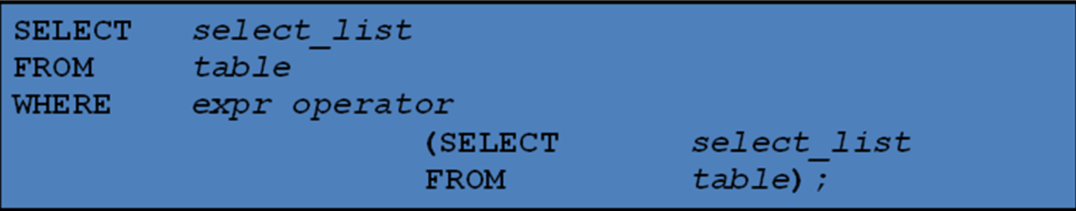

LAB TASKS:
Create tables and insert data into it using the schema provided to you. Then perform the tasks below.

- Write a query to display all the orders from the orders table issued by the salesman 'Paul Adam'.
- Write a query to display only those customers whose grade are, in fact, higher than every customer in New York.
- Write a query to display all the orders which values are greater than the average order value for 10th October 2012.
- Write a query to count the customers with grades above New York's average.
- Write a query to find the sums of the amounts from the orders table, grouped by date, eliminating all those dates where the sum was not at least 1000.00 above the maximum order amount for that date.
- Write a query that extracts the rows of all salesmen who have customers with more than one order.
- Write a query to get all the information for those customers whose grade is not as the grade of customer who belongs to the city London.

Week 8
CORRELATED SUBQUERY

Lab Objective:
- Understanding correlated subqueries in SQL.
- To run queries that depend on correlated subqueries to retrieve specific data.
- To determine how correlated subqueries vary from normal subqueries.
Correlated Subquery:
A correlated subquery is a subquery that references columns from the outer query. This dependency causes the subquery to be executed repeatedly, once for each row processed by the outer query. Correlated subqueries are commonly used for queries that need to filter data based on row-by-row comparisons.
Sample Table

CREATE TABLE departments (
dept_id INT PRIMARY KEY,
dept_name VARCHAR(50)
);

CREATE TABLE employees ( emp_id INT PRIMARY KEY,
emp_name VARCHAR(50),
salary DECIMAL(10, 2),
dept_id INT,
FOREIGN KEY (dept_id) REFERENCES departments(dept_id)
);

Insert sample data into departments table

INSERT INTO departments VALUES (1, 'Sales'),
(2, 'Marketing'),
(3, 'IT');

Insert sample data into employees table

INSERT INTO employees VALUES (1, 'Alice', 60000, 1),
(2, 'Bob', 50000, 1),
(3, 'Carol', 70000, 2),
(4, 'David', 80000, 3),
(5, 'Eve', 75000, 3);
Correlated Subquery Examples
1. Write a query to find employees whose salary is above the average salary of their respective department.
2. This query will use a correlated subquery to calculate the average salary per department.

SELECT emp_name, salary, dept_id
FROM employees e1
WHERE salary > (
SELECT AVG(salary)
FROM employees e2
WHERE e1.dept_id = e2.dept_id
);

Lab Task:

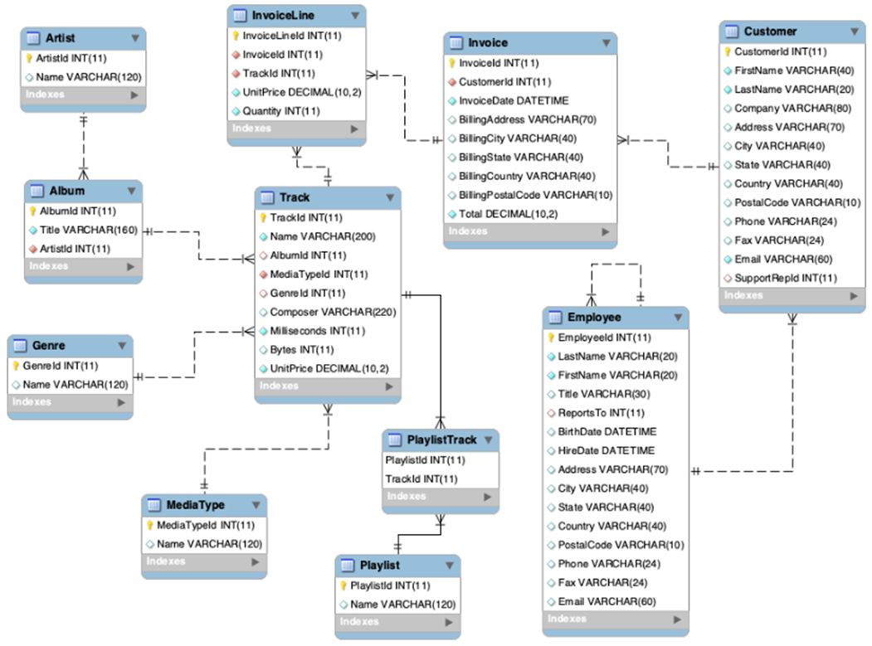
Question-01: Write a correlated subquery to Display InvoiceLine Id whose Unitprices are greater than the average Unit price of all Invoices in each InvoiceLine.
Question-02: Write a correlated to display Invoice Id, Billing city billing state and total sales in descending order.
Hint: One Sale= unitprice* quantity
Question-03: Write a query to display the employee_id, manager_id, first_name and last_name of those employees who manage other employees.
Question-04: Write a correlated subquery display invoice information having latest date.

Week 9
VIEWS AND STORED PROCEDURE

Lab Objective:
- To understand the concept of views and stored procedures in SQL.
- To create, modify, and utilize views to simplify data retrieval.
- To define, execute, and use stored procedures for reusable database operations.
Views:
CREATE VIEW view_name AS
SELECT column1, column2, ...
FROM table_name
WHERE condition;

Stored Procedures:
A stored procedure is a precompiled collection of SQL statements stored in the database, which can be executed with specific parameters.
CREATE PROCEDURE procedure_name (parameters)
BEGIN
SQL statements;
END;
Task:
Question-01: Alter the view and select only the name and number of that employees who reports to no one.
Question-02: Create a view named as last 4 digits of your registration no and display the employee’s number, employee’s name along with the Office City.
Question-03: Create and display a procedure that displays all the employees
Question-04: Create and display a procedure that displays all the records of the employees based on the office code given by the user.
Question-05: Create and displays a procedure that displays the count of the employees associated with the office code ‘6’.
Question-06: Create and displays a procedure that displays the count of the records of the employees based on their office code given by the user and then returns the result in the output variable by using multiple parameters

Week10
FUNCTIONAL DEPENDENCY
Lab Objective:
- To understand the concept of functional dependency in relational databases.
- To identify and analyze functional dependencies within a database schema.
- To understand the role of functional dependencies in normalization.
Functional Dependency:
In a relational database, a functional dependency exists when the value of one attribute (or a set of attributes) uniquely determines the value of another attribute.

Types of Functional Dependencies:
- Trivial Functional Dependency: A functional dependency is trivial if the dependent attribute is a subset of the determinant. For example, A → A is trivial.
- Non-Trivial Functional Dependency: A dependency where the dependent attribute is not a subset of the determinant.
- Partial Functional Dependency: A functional dependency in which a non-prime attribute is functionally dependent on a part of a candidate key.
- Transitive Functional Dependency: A functional dependency that exists when a non-prime attribute is dependent on another non-prime attribute through a transitive relationship.
Identify Functional Dependencies in a Sample Table
i. Create a Sample Table:
Create a table representing students, courses, and grades. This table will have attributes with functional dependencies.
CREATE TABLE StudentCourse ( student_id INT,
student_name VARCHAR(50),
course_id INT,
course_name VARCHAR(50),
instructor_name VARCHAR(50),
grade CHAR(1),
PRIMARY KEY (student_id, course_id)
);
ii. Insert Sample Data:
Insert data to illustrate functional dependencies between attributes.
INSERT INTO StudentCourse (student_id, student_name, course_id, course_name, instructor_name, grade) VALUES (1, 'Alice', 101, 'Database Systems', 'Dr. Smith', 'A'),
(2, 'Bob', 102, 'Algorithms', 'Dr. Brown', 'B'),
(3, 'Alice', 103, 'Data Structures', 'Dr. Brown', 'A'),
(4, 'Charlie', 101, 'Database Systems', 'Dr. Smith', 'C');
Identify Functional Dependencies
i. Analyze Functional Dependencies:
Based on the sample data, identify and list all functional dependencies.For example:
- student_id → student_name: The student ID uniquely determines the student’s name.
- course_id → course_name, instructor_name: The course ID uniquely determines the course name and instructor name.
- (student_id, course_id) → grade: The combination of student ID and course ID determines the grade.
ii. Determine Primary and Candidate Keys:
- Identify the primary key(s) and candidate key(s) for the table.
- In this case, (student_id, course_id) serves as the primary key, uniquely identifying each record in the table.

Task:
- List all functional dependencies in the StudentCourse table before normalization.
- Identify candidate keys for the StudentCourse table.

Week11
NORMALIZATION
Lab Objective:
- To understand the concept of normalization in relational databases.
- To practice identifying and eliminating redundancy in database tables using normalization techniques.
- To learn and implement the process of converting a table from un-normalized form to 1NF, 2NF, 3NF, and BCNF.
Outcome:
Normalization is the process of organizing a database to eliminate redundancy and improve data integrity. This lab focuses on understanding the different normal forms and how they can be applied to design an efficient relational database.
Normalization:
Normalization is the process of decomposing a database schema into smaller, well-structured tables to minimize redundancy and avoid undesirable characteristics like update anomalies, insertion anomalies, and deletion anomalies.
There are several normal forms that a relational database can satisfy:
- First Normal Form (1NF): A table is in 1NF if all columns contain atomic (indivisible) values and each record is unique.
- Second Normal Form (2NF): A table is in 2NF if it is in 1NF and all non-key attributes are fully functionally dependent on the entire primary key.
- Third Normal Form (3NF): A table is in 3NF if it is in 2NF and there is no transitive dependency (i.e., non-key attributes depend only on the primary key).
- Boyce-Codd Normal Form (BCNF): A table is in BCNF if it is in 3NF and if every determinant is a candidate key.
Create a Sample Table: We will use the following un-normalized table to demonstrate the normalization process.
CREATE TABLE Orders (
order_id INT PRIMARY KEY,
customer_name VARCHAR(50),
customer_address VARCHAR(100),
product_id INT,
product_name VARCHAR(50),
product_price DECIMAL(10, 2),
quantity INT
);
Insert Sample Data: Insert sample data into the Orders table to illustrate redundancy.
INSERT INTO Orders VALUES
(1, 'Alice', '123 Main St', 101, 'Laptop', 1200.00, 2),
(2, 'Bob', '456 Elm St', 102, 'Smartphone', 600.00, 1),
(3, 'Alice', '123 Main St', 103, 'Tablet', 450.00, 3),
(4, 'Charlie', '789 Oak St', 101, 'Laptop', 1200.00, 1);
Normalize to 1NF
- In this case, the table already has atomic values, and each order has a unique order_id, so it is already in 1NF.

Normalize to 2NF
- Identify the Primary Key: The primary key of the Orders table is a composite key (order_id, product_id).
- Remove Partial Dependency: customer_name, customer_address depend only on order_id, and product_name, product_price depend only on product_id. We need to decompose the table to remove these partial dependencies.
CREATE TABLE Orders_2NF (
order_id INT PRIMARY KEY,
customer_name VARCHAR(50),
customer_address VARCHAR(100)
);

CREATE TABLE Products (
product_id INT PRIMARY KEY,
product_name VARCHAR(50),
product_price DECIMAL(10, 2)
);
OrderDetails Table: Contains information about the quantity of products ordered, along with references to Orders and Products tables.
CREATE TABLE OrderDetails (
order_id INT,
product_id INT,
quantity INT,
PRIMARY KEY (order_id, product_id),
FOREIGN KEY (order_id) REFERENCES Orders_2NF(order_id),
FOREIGN KEY (product_id) REFERENCES Products(product_id)
);

Normalize to 3NF
- This case, customer_name and customer_address are non-key attributes that depend on order_id, but they don't depend on product_id. However, since the Orders_2NF table already contains only attributes that directly depend on order_id, no further decomposition is needed to achieve 3NF.

Normalize to BCNF
- Tables in 3NF are already in BCNF since there are no non-trivial functional dependencies where a non-candidate key determines other attributes.

Tasks:
- Normalize the Orders table to 1NF. Identify any redundancy and explain why it is a violation of 1NF.
- Normalize the Orders table to 2NF. Identify partial dependencies and explain the decomposition process.
- Normalize the Orders table to 3NF. Identify any transitive dependencies and explain the decomposition process.
- Normalize the Orders table to BCNF. Explain why the tables in 3NF are already in BCNF.

Week 12

MongoDB INSTALLATION
Lab Objectives:

- Students will learn how install MongoDB
- Setup and familiarize with MongoDB environment

Introduction to MongoDB:
MongoDB is a leading open-source NoSQL database. It is a cross-platform, document oriented database that provides high performance, high availability, and easy scalability. MongoDB works on the concept of collection and document. Unlike traditional SQL databases, MongoDB is schema-less, allowing for flexibility in how data is stored and enabling developers to quickly change database structures without downtime. Because of its flexibility and scalability, MongoDB is popular in environments where agile development is needed, such as with real-time analytics, content management systems, mobile apps, and IoT applications.

Setting up MongoDB environment
Go to mongodb website.
https://www.mongodb.com/try/download/community
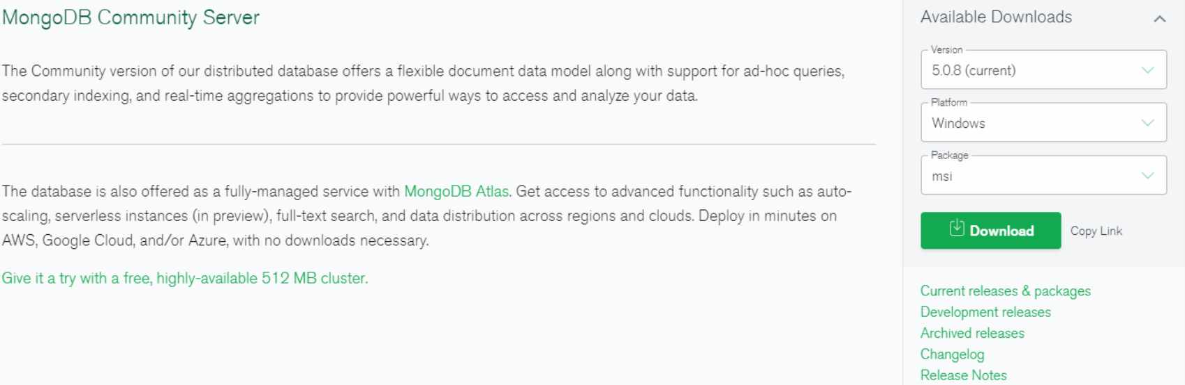
Download the setup compatible with your OS. Follow the instructions to continue installation.
Mongo Shell Installation
Uptil this point we have only installed the MongoDB server. Now we will install Mongo Shell to interact with the server.
Mongo Shell is an interactive JavaScript interface to MongoDB. It allows you to interact with a MongoDB database directly from the command line, where you can execute commands, query data, insert documents, update records, and perform various administrative tasks.
To install Mongo Shell go to
https://www.mongodb.com/try/download/shell
and download the mongosh (mongodb shell) and follow the instructions to install.

Mongo Compass Installation
MongoDB Compass is a powerful GUI for querying, aggregating, and analyzing your MongoDB data in a visual environment.
To install Mongo Shell go to
https://www.mongodb.com/try/download/compass

Week 13

MongoDB FUNCTION

Lab Objectives:

- Familiarize students with operations in MongoDB

Database
Database is a physical container for collections. Each database gets its own set of files on the file system. A single MongoDB server typically has multiple databases.
Collection
Collection is a group of MongoDB documents. It is the equivalent of an RDBMS table. A collection exists within a single database. Collections do not enforce a schema. Documents within a collection can have different fields. Typically, all documents in a collection are of similar or related purpose.
Document
A document is a set of key-value pairs. Documents have dynamic schema. Dynamic schema means that documents in the same collection do not need to have the same set of fields or structure, and common fields in a collection's documents may hold different types of data.

The following table shows the relationship of RDBMS terminology with MongoDB.

RDBMS | MongoDB
Database | Database
Table | Collection
Tuple/Row | Document
Column | Field
Table Join | Embedded Documents
Primary Key | Primary Key (Default key _id provided by mongodb itself)

Create Database in mongodb
MongoDB use DATABASE_NAME to create a database. The command will create a new database if it doesn't exist, otherwise it will return the existing database.
Syntax
Basic syntax of use DATABASE statement is as follows.
Example
If you want to create a database with the name <mydb>, then use DATABASE statement would be as follows.

How to check your database?
To check your currently selected database, use the command db.
Command to Check the database list
Show db command to check the database list
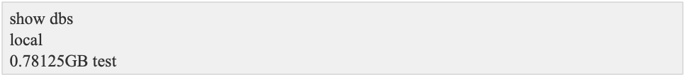
Create Collection
Command to createCollection as follows
In the command, name is the name of the collection to be created. An Options is a document and is used to specify configuration of collection

Example
Basic syntax of createCollection() method without options is as follows

In MongoDB, you don't need to create a collection. MongoDB creates collection automatically, when you insert some document.

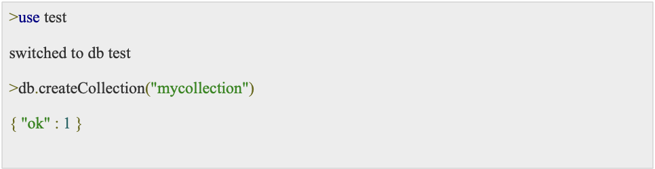

Data types in mongodb
- MongoDB supports many data types. Some of them are
- String − This is the most commonly used data type to store the data. String in MongoDB must be UTF-8 valid.
- Integer − This type is used to store a numerical value. Integer can be 32 bit or 64 bit depending upon your server.
- Boolean − This type is used to store a boolean (true/ false) value.
- Double − This type is used to store floating point values.
- Min/ Max keys − This type is used to compare a value against the lowest and highest BSON elements.
- Arrays − This type is used to store arrays or list or multiple values into one key.
- Timestamp − ctimestamp. This can be handy for recording when a document has been modified or added.
- Object − This data type is used for embedded documents.
- Null − This type is used to store a Null value.
- Symbol − This data type is used identically to a string; however, it's generally reserved for languages that use a specific symbol type.
- Date − This data type is used to store the current date or time in UNIX time format. You can specify your own date time by creating object of Date and passing day, month, year into it.
- Object ID − This data type is used to store the document’s ID.
- Binary data − This data type is used to store binary data.
- Code − This data type is used to store JavaScript code into the document.
- Regular expression − This data type is used to store regular expression

How to insert document in mongodB
To insert data into MongoDB collection, you need to use MongoDB's insert() or save() method.

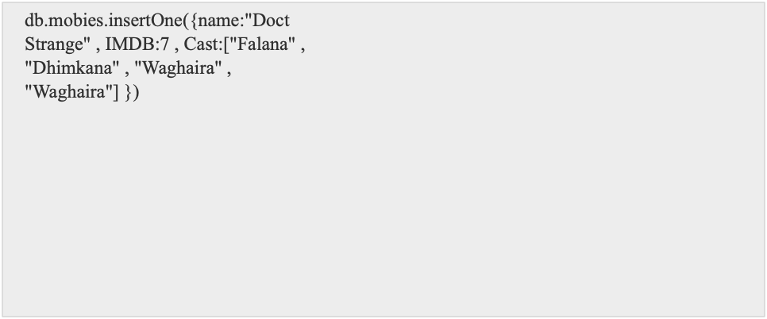

Insert Multiple document
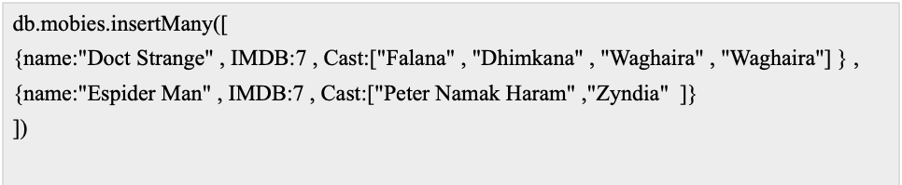

Conditions :

lt | Less Then
Gt | Greater then
lte | Less then or Equal
gte | Greater then or equal
eq | Equal

Operators
Or , and
Syntax
Db.collectionName.find({$or:[{condition 1} , {Condition 2}]})

And
Syntax
Db.collectionName.find({$and:[{condition 1} , {Condition 2}]})

Reading the Data
Get All Data In the Collection
db.mobies.find({})

Get The Specific Record
Get All Movies where IMDB Rating is Equal to 9
db.mobies.find({IMDB:{$eq:9}}
Get All Movies where IMDB Rating is greater then 6
db.mobies.find({IMDB:{$gt:6}})

Updating the record
Update All the Movies where IMDB Rating is greater then 6 to 7
db.mobies.updateMany({IMDB:{$gt:6}},{$set:{IMDB:7}})

LAB TASKS:
- To create a database name University portal
- Create a collection name student
- Insert multiple documents (like Student Record, Faculty Record, and Finance Record).
- Insert Field to the document(like Student (name, cms, cga ,semester).

Week14

MongoDB PROJECTION AND FILTERING

Lab Objectives:

- Familiarize students with projection and filtering in MongoDB

We can use logical operators and different conditions to filter out data we have obtained from find()

Conditions :

$lt | Less Then
$Gt | Greater then
$lte | Less then or Equal
$gte | Greater then or equal
$eq | Equal
$ne | Not equal

Example
Consider you have the following collection with records

Filtering based on conditions

Operators
AND
This will return employees who belong to Engineering department AND have salary greater than 70000
OR
This will return Employees who either belong to department HR or have salary less than 60000 or both.

NOT
This will return all Employees who do not belong to Engineering department.

NOR
This will return Employees where department is not HR or salary is not greater than 75000.

LAB TASKS:
- Create database Library
- Create collection books
- Insert documents into the collection having following fields:
{ title: "Clean Code", author: "Robert C. Martin", category: "Software Development", year: 2008 },
- Insert documents into the collection having following fields:

